CSS Selector: performs well as compared to XPATH and CSS will not change based upon browsers, that it will behave same in all browsers but xpath will behave differently in IE browser.

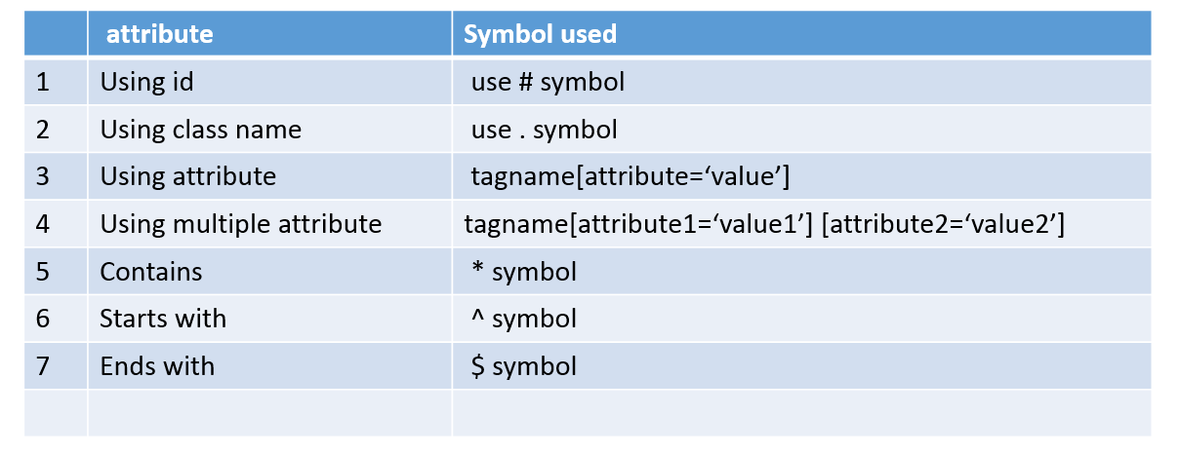

CSS Selector using String Attribute

|  |  |
| --- | --- |
|  | **Syntax- tagname[attribute='value']**  **Example- input[id='user_login']** |

CSS Selector using Multiple Attributes

Syntax- **tagname[attribute1='value1'][attribute2='value2']**

CSS Selector using id

Syntax using ID

**tagname#id**

CSS Selector using Class name

Syntax using Classname

**tagname.classname**

CSS Selector using contains

**Syntax- tagname[attribute*='value']**

CSS Selector using Start-with

**Syntax- tagname[attribute^='value']**

CSS Selector using End-with

**Syntax- tagname[attribute$='value']**